
SPECIALIST MATHS
TRIAL EXAMINATION 2
SOLUTIONS
2008

Section 1 – Multiple-choice answers

1. C 7. E 13. D 19. D
2. A 8. C 14. A 20. A
3. B 9. C 15. C 21. E
4. D 10. B 16. D 22. A
5. B 11. A 17. E
6. B 12. E 18. D

Section 1- Multiple-choice solutions

Question 1

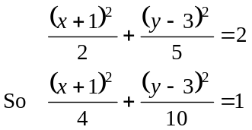
The ellipse has its centre at 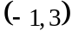 and a semi-major axis of length 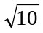 units running parallel to the y-axis.
The minimum value of y for the ellipse is therefore 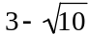.
The answer is C.

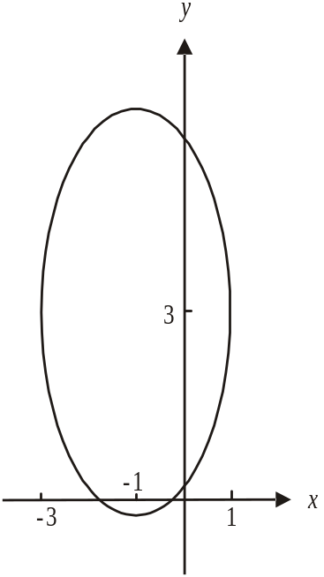

Question 2

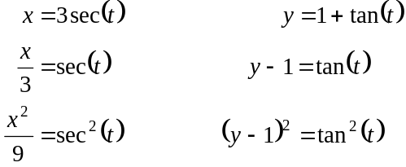

Since 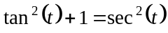 (from the formula sheet)
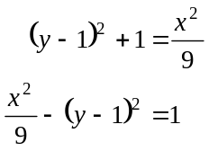
Centre is located at 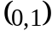.
The answer is A.

Question 3

For the function 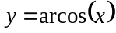, the domain is .
For the function 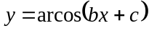 the domain is
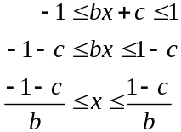

The implied domain of the function 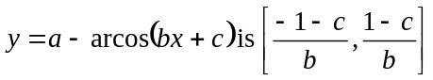.
The answer is B.

Question 4
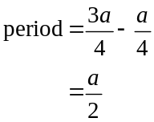
Now, for the graph of 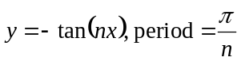.
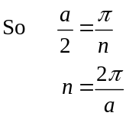
So options A. and B. are incorrect.
The graph of 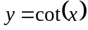 is shown.
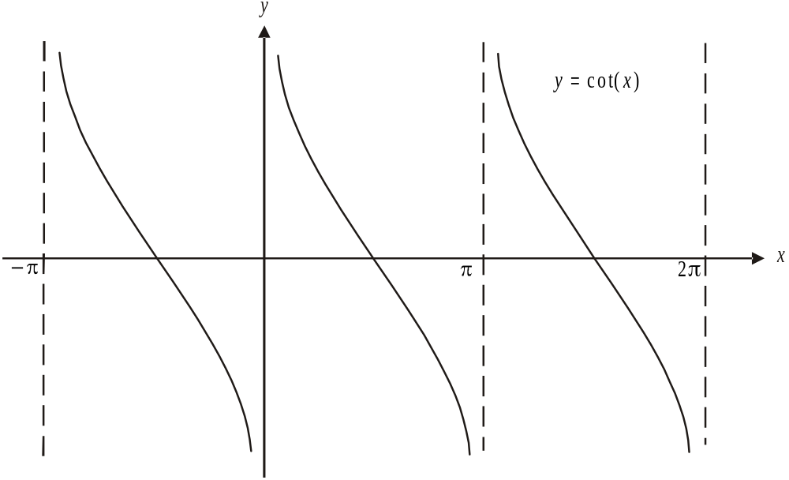

The period of the graph of 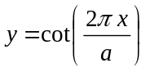 will be but the graph of must be translated units to the right or to the left to look like the graph shown in the question. The rule could therefore be 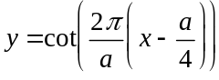.
The answer is D.

Question 5
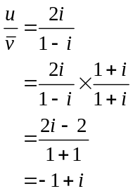
The answer is B.
Question 6

Multiplying z by i rotates the complex number z anticlockwise about the origin by 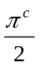.
Multiplying z by rotates the complex number z anticlockwise about the origin by 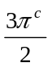.
Since 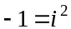, multiplying z by 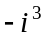 rotates the complex number z anticlockwise about the origin by 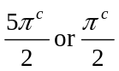.
The answer is B.

Question 7

Method 1
For 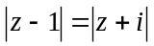, we are looking for the set of points in the complex plane such that the distance from any one of them to the complex number 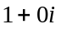 is the same as the distance to the complex number .
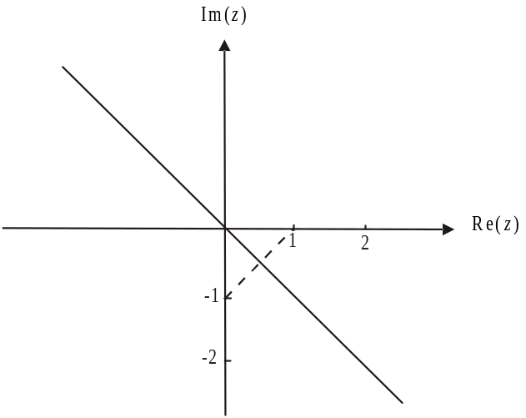

The answer is E.

Method 2
Let 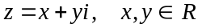.
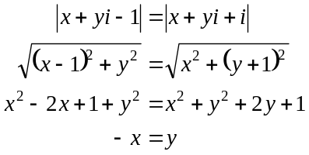
The answer is E.

Question 8
We have a truncated (“chopped off”) circle.
The full circle could be described by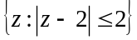.
The straight line could be described by 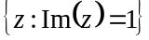.
The region could be described by 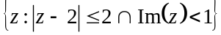
The answer is C.

Question 9

If 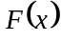 is the antiderivative of 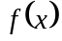 then the derivative of is ; that is, the graph of 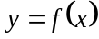 shows the gradient function of 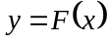. Therefore the graph of has a stationary point at 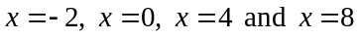. Options A and B are incorrect.
A stationary point of inflection can only occur where there is a stationary point and the gradient is positive on either side of the stationary point or negative on either side of the stationary point. This only occurs at .
Note that at 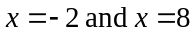 there would be a local maximum and at there would be a local minimum.
The answer is C.

Question 10
We need to find the speed at which the
ranger is moving, that is, 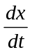.
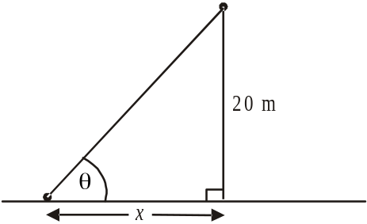

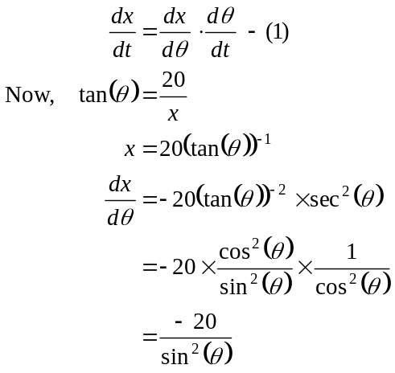
From (1), 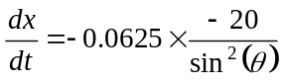
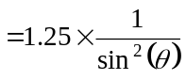
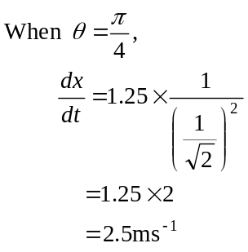
The answer is B.

Question 11

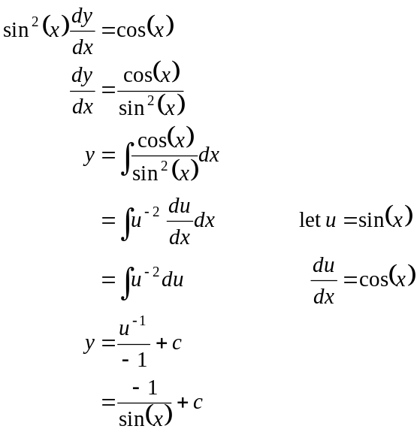
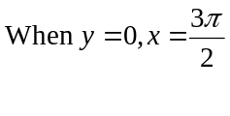
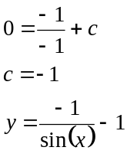
The answer is A.

Question 12
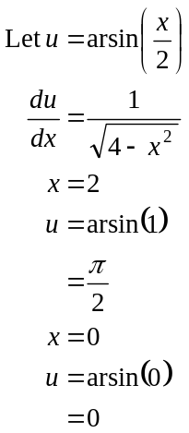
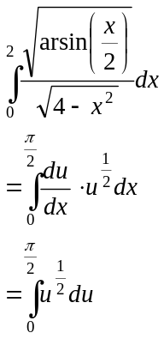
The answer is E.

Question 13
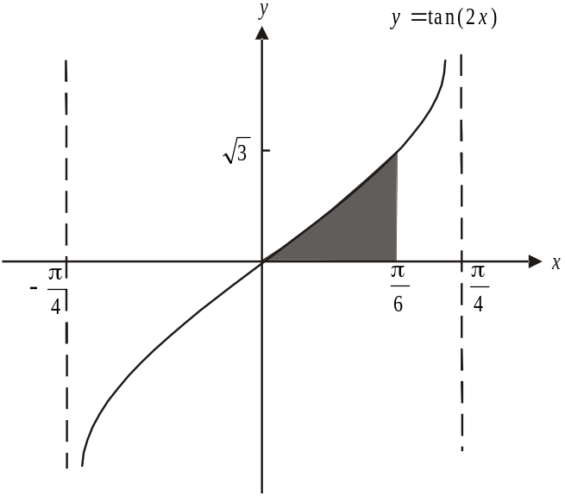

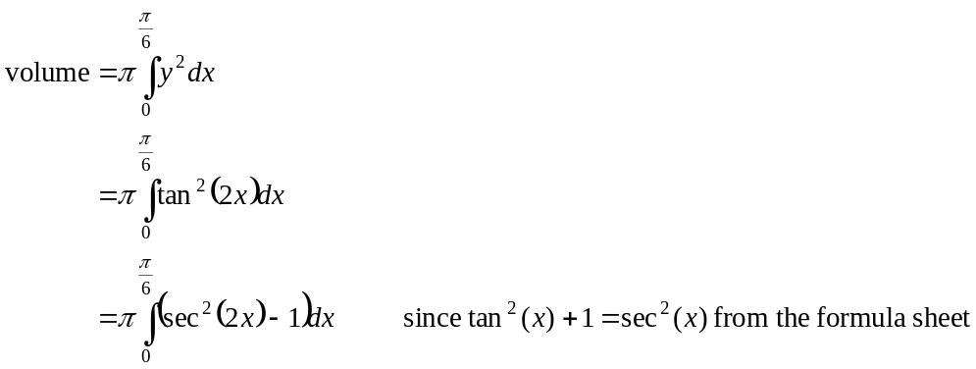
The answer is D.

Question 14

Using Eulers method,
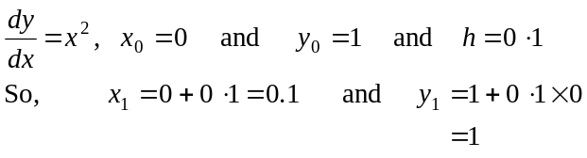
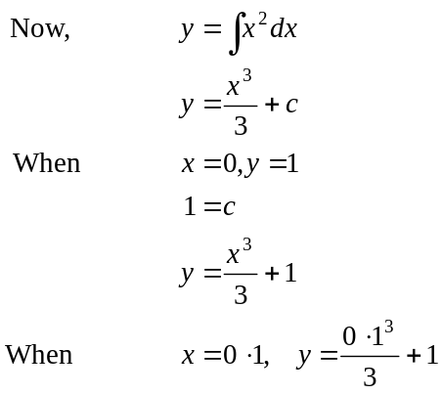
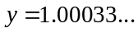
The difference is 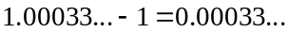
The answer is A.

Question 15

The rate of reproduction where k is a constant.
The rate of death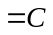 where C is also a constant.
The required differential equation is 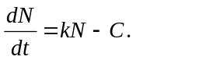
The answer is C.

Question 16

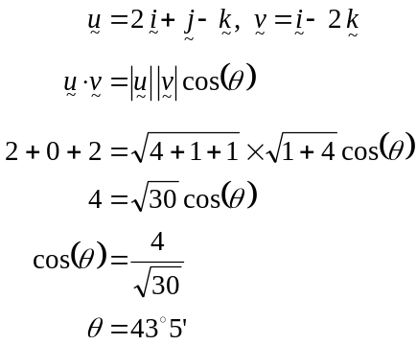
The answer is D.

Question 17

Let 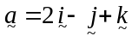 and 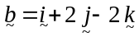.
The vector resolute of perpendicular to is 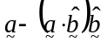.
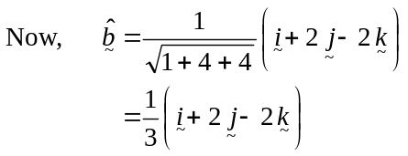
So 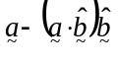
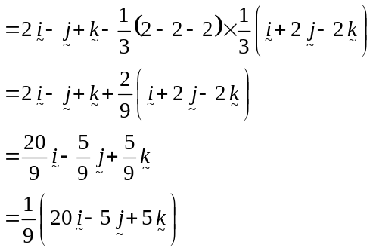
The answer is E.

Question 18

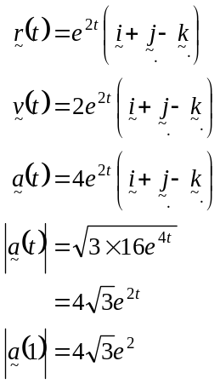
The answer is D.

Question 19

Let m be the mass of the particle in kg.
At , momentum.
At , momentum.
Change in momentum
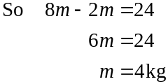
Change of momentum of the particle between given by 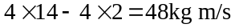.
The answer is D.

Question 20

In the first 15 secs, the particle has covered 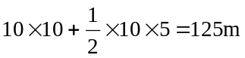 (to the right).
At it changes direction and 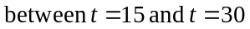covers 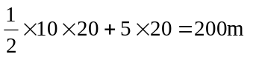 (to the left).
So at the particle is 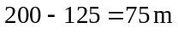to the left of its starting point.
The answer is A.

Question 21

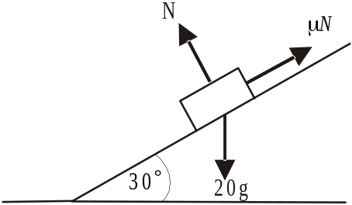

Acceleration is down the plane and hence the friction force 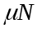 is directed up the plane.
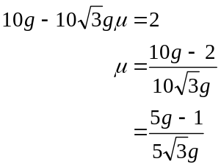
The answer is E.

Question 22
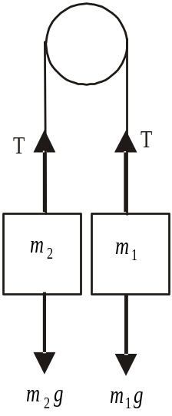
Since 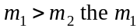 particle will accelerate
downwards and the 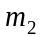 particle will accelerate
upwards.

Around the 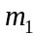 particle
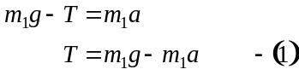

Around the particle
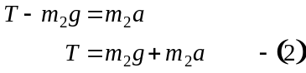
Combining (1) and (2)
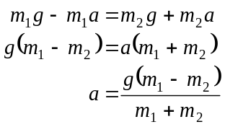
The magnitude of the acceleration of the particle (and the particle) is 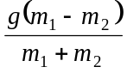 and the direction of the acceleration of the particle is downwards.
The answer is A.

SECTION 2

Question 1

- Method 1

The graph of 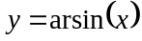; which has a maximal domain of 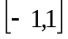, has been dilated from the y- axis by a factor of 2 to produce the graph of 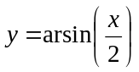.
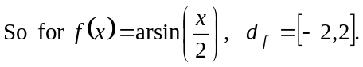 (1 mark)
Method 2
The graph of has a maximal domain of so 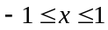.
For the graph of , 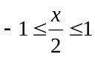
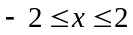
(1 mark)

- i. and ii.
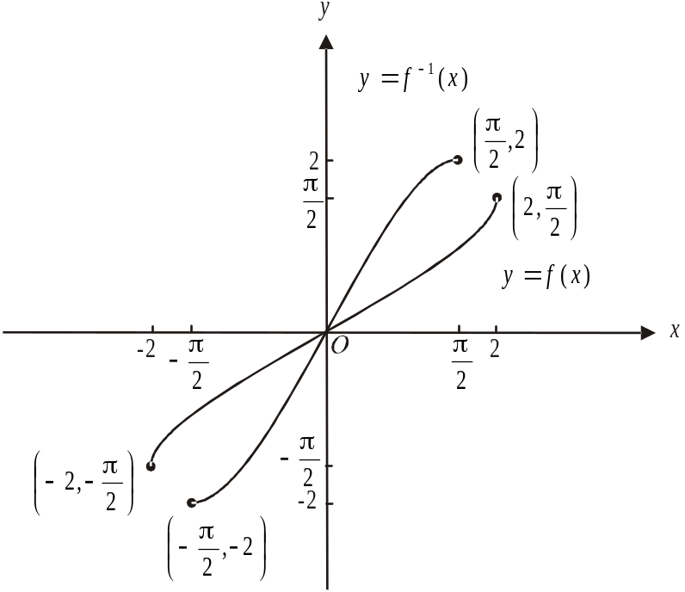

(1 mark) graph of
(1 mark) graph of 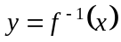

- 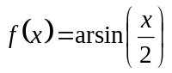
Let
Swap x and y for inverse.
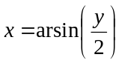
Rearrange
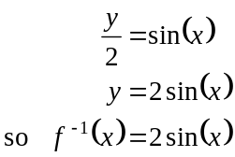
(1 mark)
d. i.
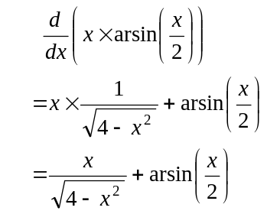 (product rule)
(1 mark)

- From i.,
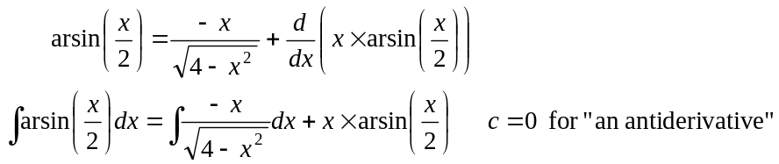
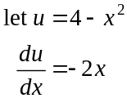
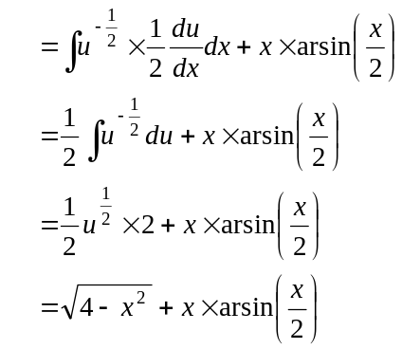
(1 mark)
(1 mark)

- From the graph,

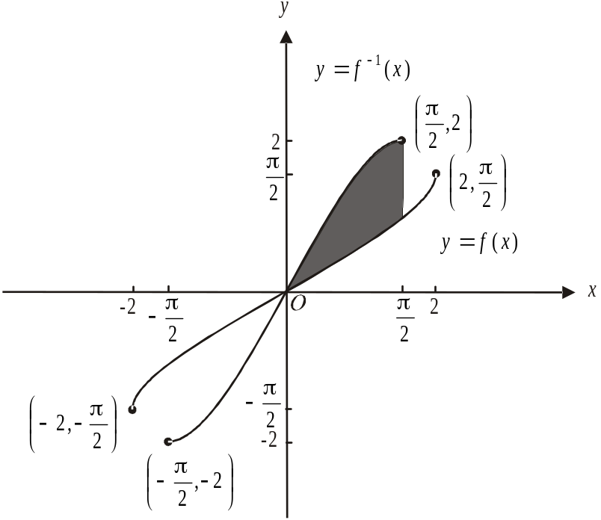

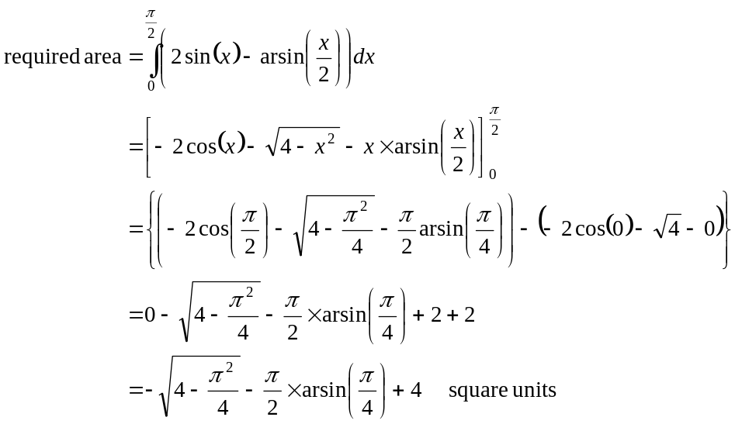
(1 mark)
(1 mark) – this step must be shown because of the term “hence” in the question
(1 mark)
Total 10 marks

Question 2

- Method 1 – use a calculator
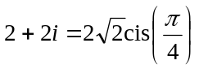
(1 mark)
Method 2 – by hand
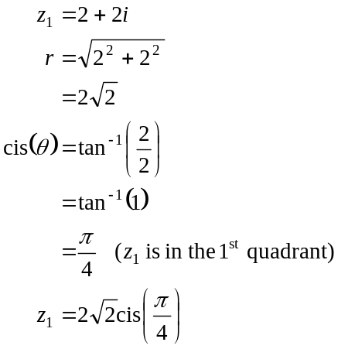
1 mark)
- i. 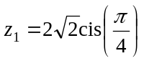

  - 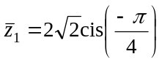

  - 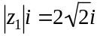
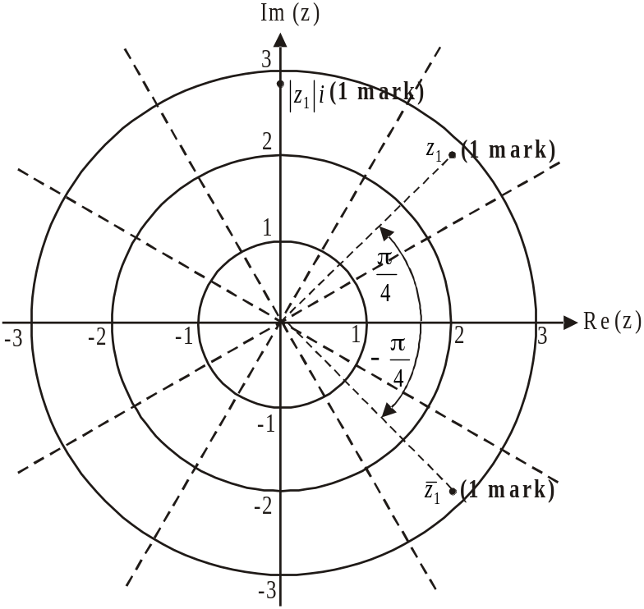

c.
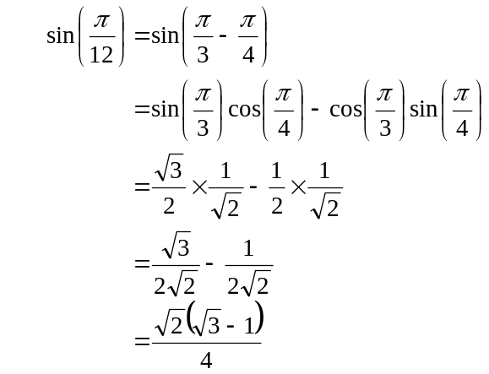
(1 mark)
(1 mark)
as required
- Method 1
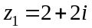
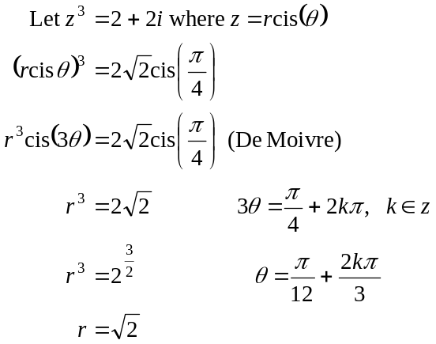
(1 mark)
(1 mark)
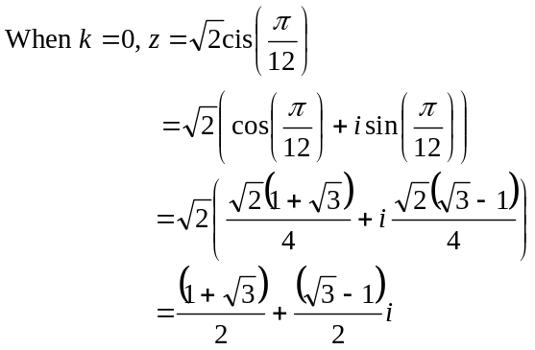
as required.
(1 mark)
Method 2
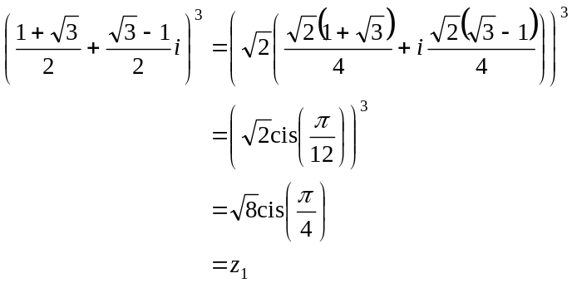
(1 mark)
(1 mark)
(1 mark)

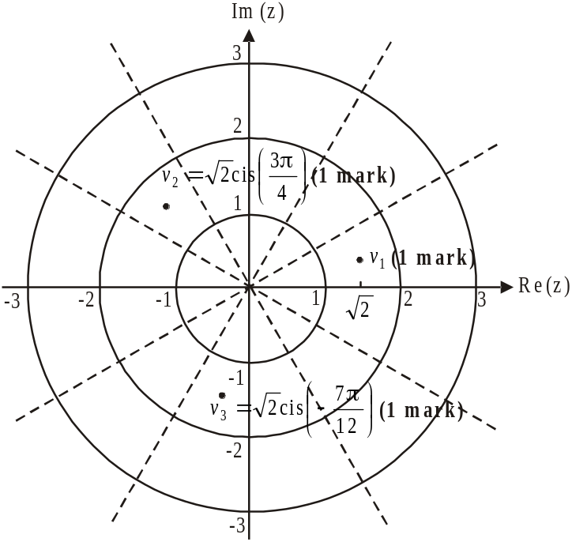

  - From part d., when
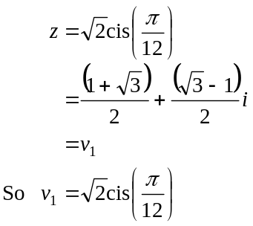

  - There are three cube roots of spaced evenly around a circle of radius 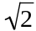 units. They are spaced 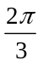 apart.

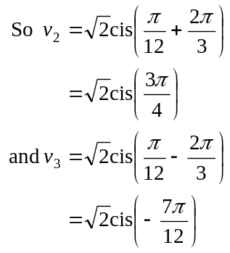
or vice-versa.

f. Show that 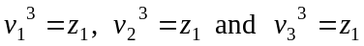.

From e., 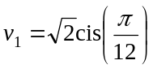
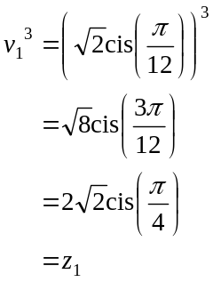

From e., 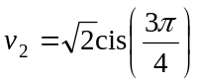
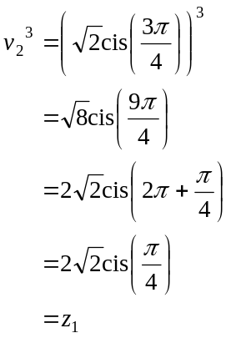

From e., 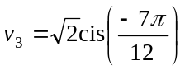
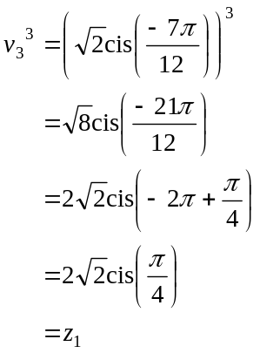
(1 mark) for correct attempt
(1 mark) for correct results
Total 14 marks

Question 3

- i. We have constant (uniform) acceleration so we can use the formula
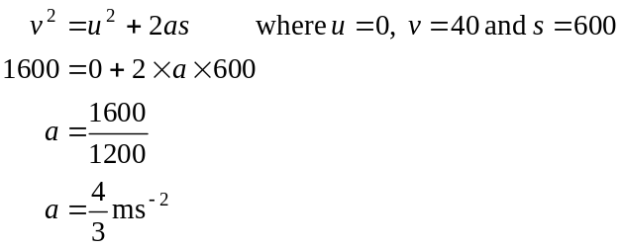
(1 mark)

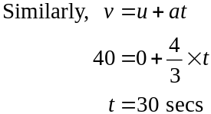

(1 mark)

- The equation of motion is given by

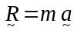
where represents the resultant forces acting on the cyclist and his bicycle.
Because the cyclist’s motion is along a straight line, we have
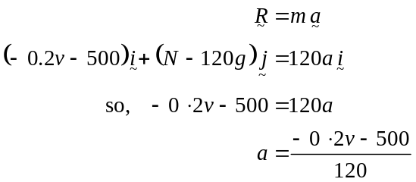
(1 mark)

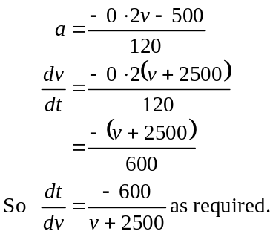

(1 mark)

- Method 1
From part c.,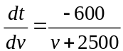
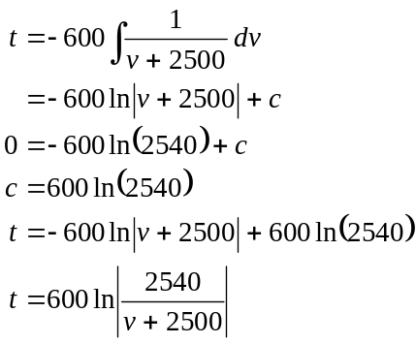
(1 mark)
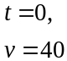
(1 mark)
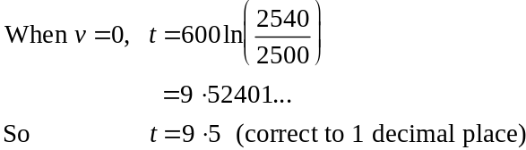
(1 mark)

Method 2

The time it takes to come to rest is given by
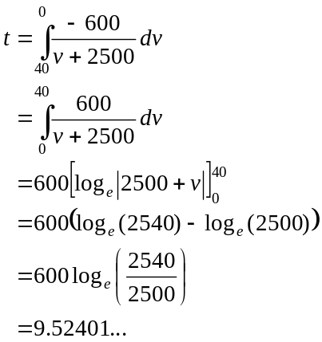
(1 mark)
(1 mark)
So 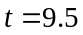 (correct to 1 decimal place) (1 mark)
e. Method 1
From part d.,
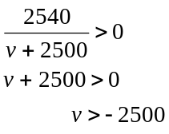
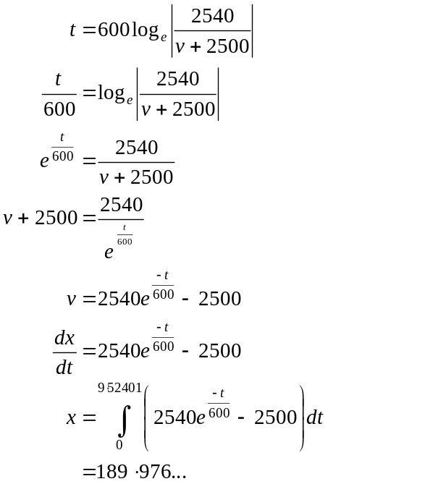
(1 mark)
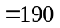m (to the nearest metre)
(1 mark)
Method 2
From part b.,
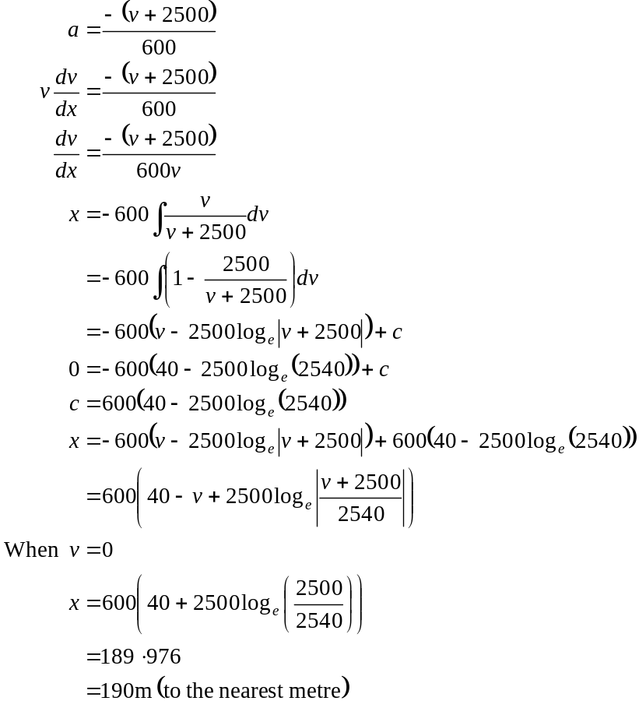
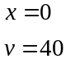
(1 mark)
(1 mark)

Method 3

Required distance is given by
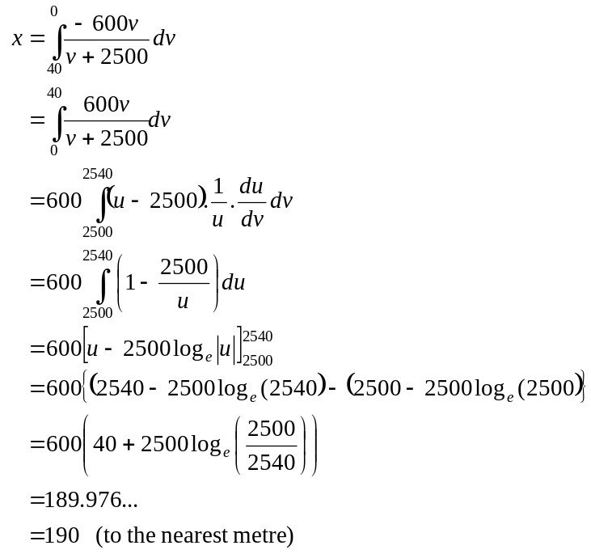
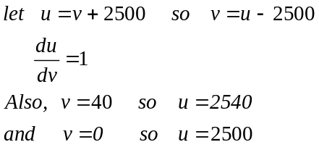
(1 mark)
(1 mark)
Total 9 marks

Question 4

- Mark in the forces operating.

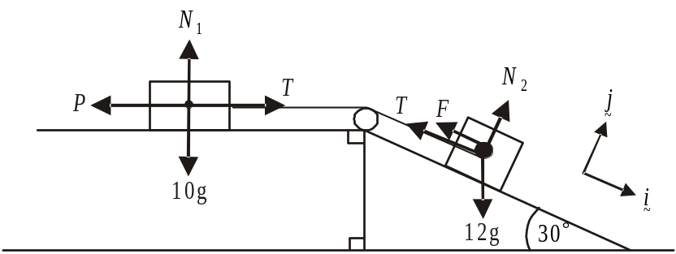

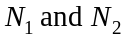 are the normal forces acting on the 10kg and 12kg masses respectively. F is the friction force of the inclined plane on the 12kg mass.

Around the 10kg mass

The 10kg mass will accelerate to the right so there must be a net force to the right.
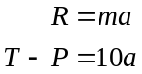
Now, 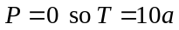

Around the 12kg mass

(equation of motion)
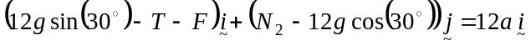
(1 mark)
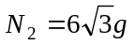

Also, 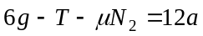
so 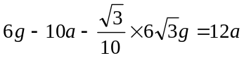
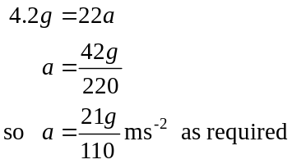
(1 mark)

- If 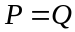, then the 12kg mass is at the point of sliding down the inclined plane (ie. limiting equilibrium).

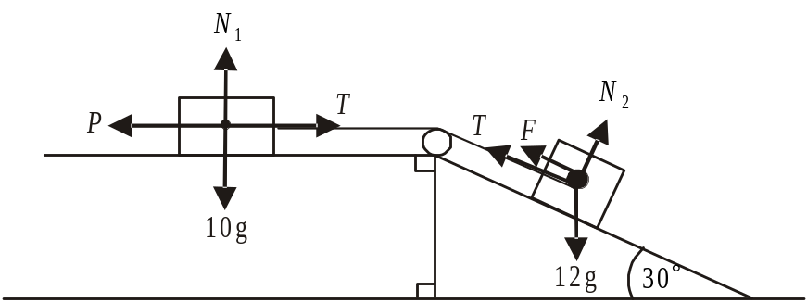

The friction force F is therefore directed up the inclined plane.
Now, resolving around the 10kg mass we have 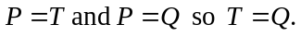

Around the 12kg mass
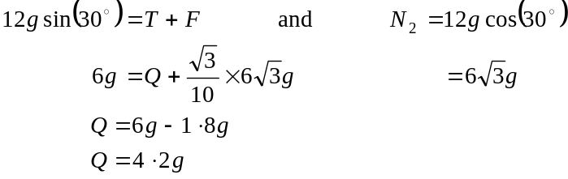
(1 mark)
If , then the 12kg mass is at the point of sliding up the inclined plane and therefore the friction force is directed down the inclined plane.
Now, resolving around the 10kg mass we have 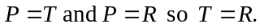
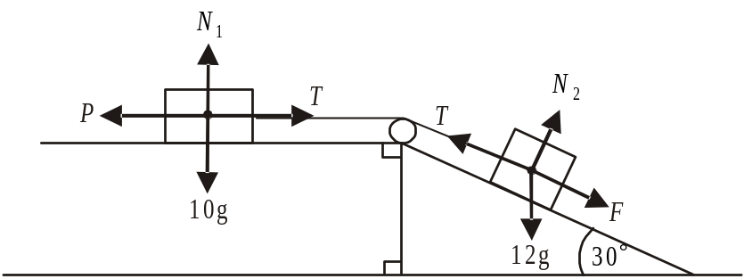

(1 mark) – giving some indication that the friction force is directed down the plane.

Around the 12kg mass
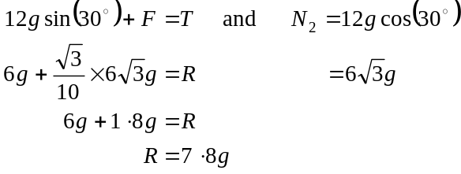
(1 mark)

- In part b., we found 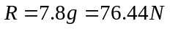
When , the 12kg mass is at the point of moving up the inclined plane and therefore when , the 12kg mass will be accelerating up the inclined plane.
(1 mark)
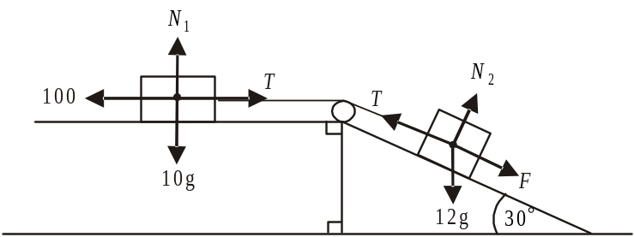

Around the 10kg mass
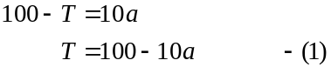
Around the 12kg mass
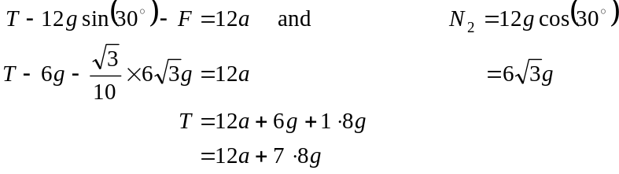
Using (1)
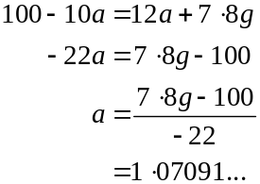
(1 mark)
The 12kg mass will accelerate at 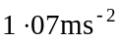 (to 3 significant figures) up the plane.
(1 mark)

- Once the string is disconnected, 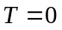.
Around the 12kg mass
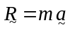
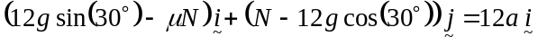
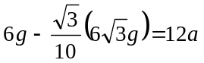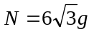
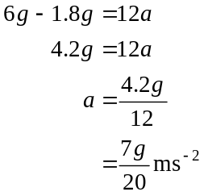
(1 mark)

Since acceleration is constant, we can use the formula
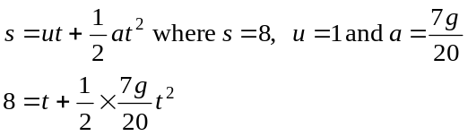

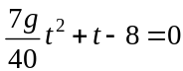
(1 mark)
(1 mark)
- As with part d., the acceleration is 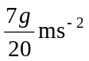 but .
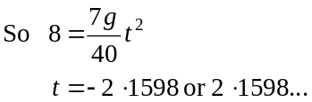
(1 mark)
Total 12 marks

Question 5

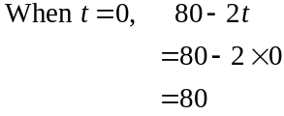

The kite is 80m above the ground when the monitoring begins.
(1 mark)

- i. The kite hits the ground when
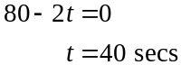
(1 mark)

  - The position vector of the kite when it has hit the ground is
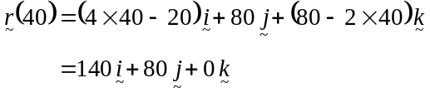
(1 mark)
The distance from the recording device is given by
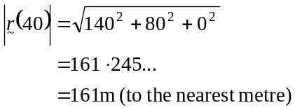
(1 mark)
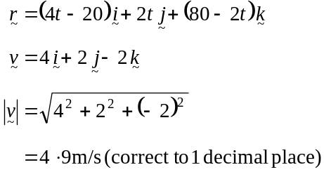

(1 mark)

(1 mark)

- From part c. the kite is travelling at a constant speed of 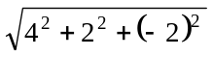 m/s.
It travels for 40 secs before it hits the ground. (1 mark)

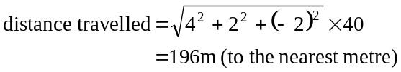
(Check units 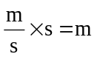.)
(1 mark)

- Method 1
We need to find the angle that the velocity vector makes with the horizontal ground.
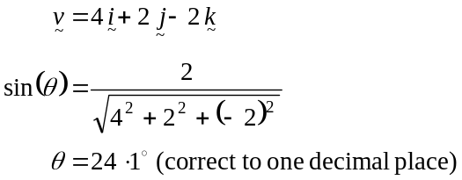
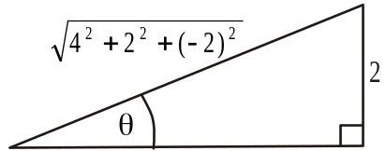
The required angle is 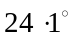
(1 mark) using
(1 mark) correct answer
Method 2
The required angle can be found by finding the angle between the vectors
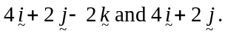
Now, 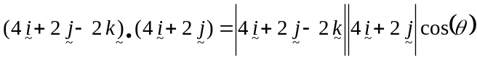 (1 mark)
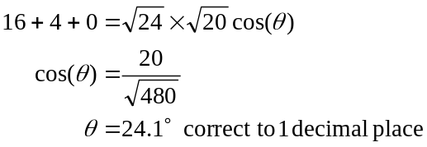
(1 mark)
- The vector is the vector in the east direction. When 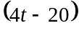 is a maximum, the kite will be furthest east. This happens at when the kite has hit the ground.
(1 mark)

- Method 1
The kite is closest to the recording device when
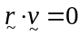 (1 mark)
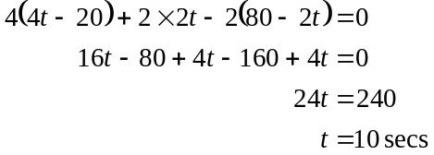
(1 mark)
Method 2

distance 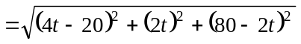 (1 mark)
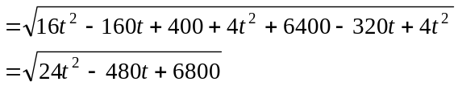
Using a CAS calculator , the minimum distance is 66.33 when t=10 seconds.
(1 mark)

Total 13 marks

